The Fourth Sunday in Lent
March 26, 2017

Sayville Congregational
United Church of Christ

Meditation

From The Gospel of Thomas
an Early Wisdom Gospel

Yeshua said,
If your leaders tell you, “Look, the kindom is in heaven,”
then the birds of heaven will precede you.
If they say to you, “It’s in the sea,”
then the fish will precede you.
But the kindom is inside you and it is outside you.
When you know yourselves, then you will be known,
and you will understand that you are children of the living God.
But if you do not know yourselves,
then you will dwell in poverty and you are poverty.

Welcome

Ringing of the Bell

Prelude “Prelude No. 3, in G Major” from 24 Preludes and Fugues, Op. 87
by Dmitri Shostakovich

*Call to Worship (Adapted from Paul’s Letter to the Ephesians)
Light always follows darkness. Always.
“For once you were in darkness,
but now in the presence of Jesus –
you are in the light.”
Live, then, as people of the Light,
For the witness of the Light is in all things
good and right and true.
Come, let the light precede us,
and let us worship God together.

*Processional Hymn New Century Hymnal #222: My Song is Love Unknown

Unison Prayer (Together) (Adapted from Faith and Worship))

For your embracing love,
a love that sees all we are and forgives us;
a love that sees our joys and sorrows and embraces us;
a love that knows no ending or beginning;
the love that could die for others and did;
we give you thanks, present, here,
in your light. Amen

A moment of silence follows.

Assurance of Pardon (Gospel of Philip 79.25-31in NHL 147, Farming - Modified)
Faith is our earth, in which we take root; hope is the water through which we are nourished; love is the air through which we grow; gnosis is the light through which we become fully grown. In this light we are baptized and meant to grow in faith, always moving toward hope, love and understanding. And in the midst and abundance of these gifts is the assurance of God’s pardon beyond all we know.
*Passing of the Peace

Reading Psalm 23 A David Psalm

From The Message

God, my shepherd!
I don’t need a thing.
You have bedded me down in lush meadows,
you find me quiet pools to drink from.
True to your word,
you let me catch my breath
and send me in the right direction.
Even when the way goes through
Death Valley, I’m not afraid
when you walk at my side.
Your trusty shepherd’s crook
makes me feel secure.
You serve me a six-course dinner
right in front of my enemies.
You revive my drooping head;
my cup brims with blessing.
Your beauty and love chase after me every day of my life.
I’m back home in the house of God for the rest of my life.

From the King James Version

The Lord is my shepherd; I shall not want.
He maketh me to lie down in green pastures: he leadeth me beside the still waters.
He restoreth my soul: he leadeth me in the paths of righteousness for his name's sake.
Yea, though I walk through the valley of the shadow of death, I will fear no evil: for thou art with me; thy rod and thy staff they comfort me.
Thou preparest a table before me in the presence of mine enemies: thou anointest my head with oil; my cup runneth over.
Surely goodness and mercy shall follow me all the days of my life: and I will dwell in the house of the Lord for ever.

Here ends this morning’s readings.

Children’s Message

Musical Praise “He Shall Feed His Flock/Come Unto Him”
From Handel’s Messiah; Karen Maust, Soprano Solo
Sermon

A moment for reflection…

*Hymn New Century Hymnal #223 What Wondrous Love is This

Prayer for Others and Ourselves

The Lord's Prayer – The Prayer of Jesus (Please say this prayer as you know it.)

Musical Praise “O mio bambino caro” from Gianni Schicchi, by Giacomo Puccini,
James Cearem, Solo Trumpet

Invitation to Give
Thank you for your generosity in helping us to share God's love for all. We are grateful for all the ways you participate in the work of this ministry, and more than anything, we are most grateful that you are here. We welcome your offerings at this time and invite you to place your prayer and information cards in the basket.

Offertory

*Doxology
We praise thee, O God, our Redeemer, Creator;
in grateful devotion, our tribute we bring.
We lay it before thee, we come and adore thee,
We bless thy holy name, glad praises we sing. Amen.

A Time for Brief Announcements

*Closing Hymn New Century Hymnal #547: Amazing Grace

Benediction and Sending Forth

The Bell is Rung

Choral Blessing “Amen” from St. Matthew Passion by J.S. Bach
Words from Saint Patrick’s Breastplate; Setting by John Rutter

Postlude “Fugue No. 3, in G Major” from 24 Preludes and Fugues,
Op. 87 by Dmitri Shostakovich
Announcements!

Next Sunday, April 2, 2017

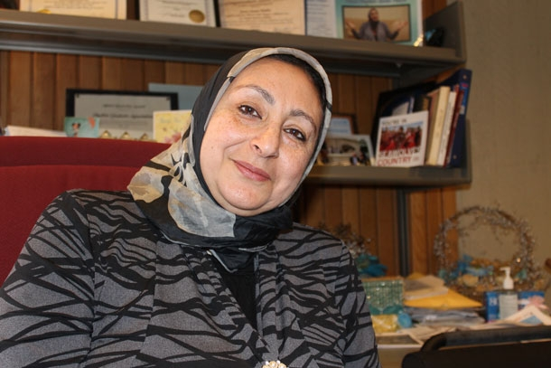
Muslim Educational Forum 11:30 AM – 1:00PM, with Sister Sanaa Nadim, Muslim Chaplain at Stony Brook University. This will conversation will take place during our Talkback time following worship. This is the beginning of a broader discussion to follow in the months ahead, as we learn more about the lives of our sisters and brothers who are Muslim and how we can grow together in the love of God we share. Sister Sanaa is a highly respected leader of the Long Island Interfaith community, and we are fortunate to have her with us for this informative gathering. Please be sure to join us.

The Spirituality of Addiction & Recovery: The Music of Those Lost & Spared
Sunday, April 2, 2017 - 7:00 PM; Congregational Church of Patchogue, 95 East Main St; 631-475-1235 ($10 suggested donation but no one turned away for lack of money) Featuring music of: The Doors, Janis Joplin, Amy Winehouse, Jerry Garcia, Prince, Whitney Houston, Johnny Cash, Red Hot Chili Peppers, Phish, James Taylor, Eric Clapton & John Lennon. Proceeds support the outreach ministries of Congregational Church of Patchogue.

Today!
Please join us for refreshments after worship in the Vestry
“A Talkback!” will follow today’s service from 11:25 - Noon! All are welcome!

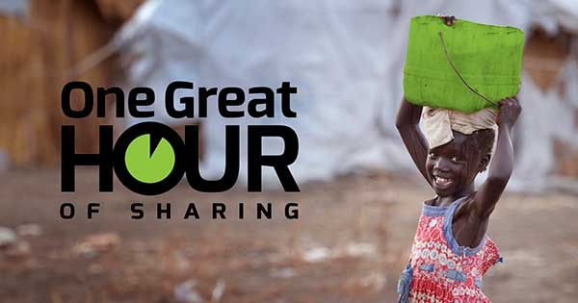
One Great Hour of Sharing®, as part of Our Churches Wider Mission, is the special mission offering of the United Church of Christ that carries God’s message of love and hope to people in crisis. The UCC works with international partners to provide sources of clean water, food, education and health care, small business micro-credit, advocacy and resettlement for refugees and displaced persons, and emergency relief and rehabilitation. OGHS also supports domestic and international ministries for disaster preparedness and response. Please consider a donation using the enclosed envelopes.

Stop & Shop Cards are available at coffee hour each week. They make great gifts and/or a great way to purchase your groceries while supporting our church.

General Contributions: United Church of Christ congregations pays its own bills, hires its own staff, and maintains its own facilities from the voluntary gifts of members and friends. Donations are accepted in the basket on Sundays, as well as through our online giving program or through direct payments. Please call Heather in the office to answer any questions you may have about how we can best to accommodate your gifts.

Upcoming Worship Schedule

Lenten, Passion Week and Easter Worship
April 2 Fifth Sunday in Lent Psalm 130 Communion Sunday
April 9 Palm Sunday Psalm 118; Matthew 21:1 – 11
April 13 Maundy Thursday 8:00 PM
April 14 Good Friday Sanctuary Open 11 AM – 4:00 PM
April 16 Easter Sunday Colossians 3:1-4; Matthew 28:1-10
Sunrise Service Depart Sayville Ferry at 6:00 AM; Board 5:45 AM
Morning Service 10:00 AM - Sanctuary

Upcoming Calendar Dates:
Monday March 27th 11:45AM Bible Talk in Vestry: Psalm 130; Palm Sunday I
Monday March 27th 5:30 PM Having Friends Inn Outreach, Fellowship Hall
Monday March 27th 7:00 PM Sayville Congregational UCC Trustees Meeting
Monday March 27th 7:30 PM Narcotics Anonymous Meeting, Fellowship Hall

Tuesday March 28th 9:30 AM Senior Exercise in the Vestry
Tuesday March 21th 7:00 PM Bible Talk in Vestry: Psalm 130; Palm Sunday I
Tuesday March 21th 5:30 PM Having Friends Inn Outreach

Wednesday March 22th 6:00 PM Choir Practice
Wednesday March 22th 5:30 PM Having Friends Inn Outreach
Wednesday March 22th 7:30 PM Narcotics Anonymous Meeting, Fellowship Hall

Thursday March 23th 10:00 AM Prayer Shawl Ministry in the Vestry
Thursday March 23th 12:15 PM Senior Exercise in the Vestry
Thursday March 23th 5:30 PM Having Friends Inn Outreach

Saturday March 25th 11:00 AM Twelve Step Meeting, Fellowship Hall
Saturday March 25th Family Table Distribution

Sunday April 2nd 11:30 AM Muslim Educational Forum/Talkback
Newsletters: Are you receiving our weekly newsletters: eChimes and Justice Chimes Newsletters? Let us know: ray@sayvilleucc.org. Visit our website for more information. at www.sayvilleucc.org. Do you need these in print?

Hospitality Hosts, Greeters, Ushers, Projectionists Needed! Please sign up to assist in worship for Sundays throughout 2017 If you can help in any of these ways, Sign up on the forms in the hallway or contact Sue Lanchantin for more information.

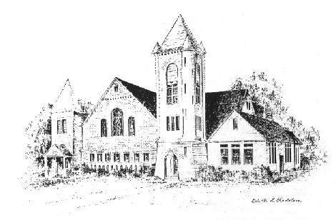
Sayville Congregational United Church of Christ
For more than a century and a half, Sayville's Congregational Church has served families on the South Shore and been a voice for the progressive Protestant tradition. A member of the United Church of Christ since it was established in 1957, today we continue to celebrate God's love, to speak for the oppressed, and to welcome those rejected by other churches. To learn about membership, please speak with any deacon.

Music Director Sean Cameron
Greeter/Ushers Jerry Avolio and Ginny McLaughlin
Liturgist Karen Maust
Projection Slides Kimberley Reiser
Projectionist Casey Cunningham
Hospitality Karin and Mark Conrad
Pastor: Ray Bagnuolo, ray@sayvilleucc.org 631-827-8611 (Cell/Text)

Sayville Congregational United Church of Christ
131 Middle Road, Sayville, NY 11782-3101
631-589-1519; churchadmin@sayvilleucc.org
www.sayvilleucc.org; www.facebook.com/sayvilleucc
Heather Corcoran, Church Administrator; eChimes Editor

Thank you for being with us today.
Peace. Shalom. Salaam. For the ways of peace are many.
“Namaste”

Please use this form to order Easter Plants for our Chancel. There are hard copies of this form in the Vestry and online. Visit www.sayvilleucc.org to download a copy of this form. Orders are due on Wednesday, April 5th. Please contact Heather if you have questions of need any additional help.

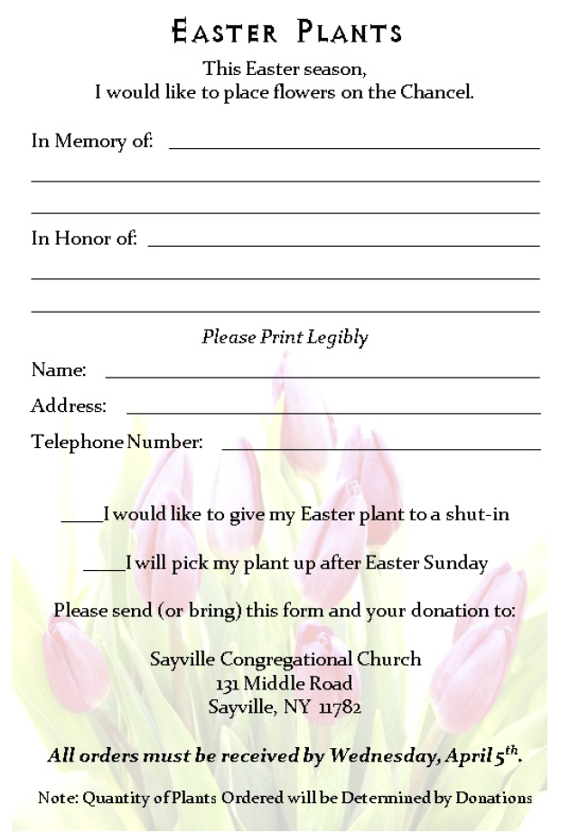

The Gospel of Thomas: Nag Hammadi library, Codex II, 2, pp. 32,10 to 51,28, and in the Greek fragments in Oxyrhynchus Papyrus I, 654 and 655; translated from the Coptic by Marvin Meyer. (Resource: The Gnostic Bible.Shambhala Publications, Inc., Boston Massachusetts. 2009. P.45

