The Fifth Sunday in Lent
April 2, 2017

Communion Sunday

Sayville Congregational
United Church of Christ

Meditation

⌘⌘⌘

“Design in art, is a recognition of the relation between various things,
various elements in the creative flux. You can’t invent a design.
You recognize it, in the fourth dimension.
That is, with your blood and your bones, as well as with your eyes.”
D. H. Lawrence
⌘⌘⌘

The person who walks in the dark does not know where she or he is going.
Believe in the light. Then the light will be within you,
shining through your lives. You’ll be the children of light.
John 12:35b

Welcome

Ringing of the Bell

Prelude “Prelude No. 7, in A Major”
from 24 Preludes and Fugues, Op. 87
by Dmitri Shostakovich

*Call to Worship (based on Psalm 31)

Praise God,
who has shown us the power of unfailing love,
and who from that love leads and guides us.

We place our trust in you, God;
Our lives are in your love.

Let your light and love shine upon us
As we come together in worship and praise. Amen.

*Processional Hymn NCH #554 Out of the Depths, O God, We Call

Unison Prayer (Together)
God, you know how we are.
We forget things.
We forget you are everywhere,
not just where we say you are.
We forget that no words really describe you,
no matter how we say you are.
Even so, you are with us, always.
You are. Words and places aside.
You are.
Let us remember
whenever we forget. Amen.

Assurance of Pardon

*Passing of the Peace

Reading Psalm 130
The Message (MSG) (Adapted) New Revised Standard Version (NRSV)

Help, God—
the bottom has fallen out of my life!
God, hear my cry for help!
Listen hard! Open your ears!
Listen to my cries for mercy.

If you, God, kept records on wrongdoings,
who would stand a chance?
As it turns out, forgiveness is your habit,
and that’s why you’re worshiped.

I pray to God—my life a prayer—
and wait for what God will say and do.
My life’s on the line before God,
my God,
waiting and watching till morning,
waiting and watching till morning.

With Israel, wait and watch for God—
with God’s arrival comes love,
with God’s arrival comes generous redemption.
No doubt about it—God will redeem us,
Redeem us back from captivity to freedom.

Out of the depths I cry to you, O Lord.
Lord, hear my voice!
Let your ears be attentive
to the voice of my supplications!

If you, O Lord, should mark iniquities,
Lord, who could stand?
But there is forgiveness with you,
so that you may be revered.

I wait for the Lord, my soul waits,
and in God’s word I hope;
my soul waits for the Lord
more than those who watch for the morning,
more than those who watch for the morning.

O Israel, hope in the Lord!
For with the Lord there is steadfast love,
and with God is great power to redeem.
It is God who will redeem Israel
from all its iniquities.

Here ends this morning’s readings.
Musical Praise “The Lord Bless You and Keep You”
by John Rutter

Children’s Message

Sermon “Broken to Open”

A moment for reflection…
*Hymn SPP #65 As the Grain Was Scattered

Prayer for Others and Ourselves

The Lord's Prayer – The Prayer of Jesus (Please say this prayer as you know it.)

Invitation to Give
Thank you for your generosity in helping us to share God's love for all. We are grateful for all the ways you participate in the work of this ministry, and more than anything, we are most grateful that you are here. We welcome your offerings at this time and invite you to place your prayer and information cards in the basket.

Offertory

*Doxology
We praise thee, O God, our Redeemer, Creator;
in grateful devotion, our tribute we bring.
We lay it before thee, we come and adore thee,
We bless thy holy name, glad praises we sing. Amen.

A Time for Brief Announcements

Invitation to the Table
Jesus said:
I am the bread of life.
You who come to me shall not hunger;
You who believe in me shall never thirst.

In company with all who hunger for spiritual food,
we come to this table to know the risen Christ
in the sharing of this life-giving bread.

Communion Prayer
God be with you.
And also with you.

Lift up your hearts.
We lift them up to God.

Let us give thanks to God Most High.
It is right to give God thanks and praise.

Pastor continues with the Communion Prayer…
Church Covenant (Sung in Unison)
In response to God’s love, we covenant with each other
to be faithful to the demands and inspiration of the eternal spirit,
revealed in the event of Jesus Christ;
to accept and respect each other with love and concern
in our worship and witness;
to reach out with the courage of our convictions in the cause of justice, liberation and equality for all;
In this, we covenant to keep the ultimate promise; “I care, I am with you.”

Sharing of the Elements:
Leader: These are the gifts of God for the people of God.

Communion Responses: The Bread of Life ~ The Cup of Blessing

Prayer of Thanksgiving
We thank you God, for inviting us to this table to remember your active presence and call in our lives. We are grateful for the new and right spirit of this communion with you today, tomorrow and every day. May it be so. Amen.

Benediction and Sending Forth

*Hymn NCH #190 Beneath the Cross of Jesus

Choral Blessing “A Closing Prayer”
by Don Besig

Postlude
⌘⌘⌘

Thank you for being with us in worship this morning.
We invite you to gather with us for refreshments in the vestry.

This morning’s “Talkback” will begin at 11:30 AM with our guest
Sister Sanaa Nadim, Muslim Chaplain at Stony Brook University.
Please join us.

⌘⌘⌘

Announcements!

Join us today following worship and refreshments in the sanctuary for the

Muslim Educational Forum with
Chaplain Sister Sanaa Nadim from Stony Brook University

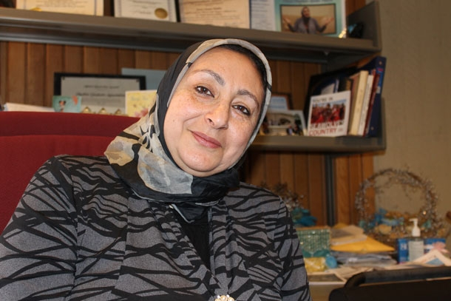
This is the beginning of a broader discussion to follow in the months ahead, as we learn more about the lives of our sisters and brothers who are Muslim and how we can grow together in the love of God we share. Sister Sanaa is a highly respected leader of the Long Island Interfaith community, and we are fortunate to have her with us for this informative gathering. Please be sure to join us.

And, tonight at 7:00 PM at the Congregational Church of Patchogue

The Spirituality of Addiction & Recovery: The Music of Those Lost & Spared
Sunday, April 2, 2017 - 7:00 PM; Congregational Church of Patchogue, 95 East Main St; 631-475-1235 ($10 suggested donation but no one turned away for lack of money) Featuring music of: The Doors, Janis Joplin, Amy Winehouse, Jerry Garcia, Prince, Whitney Houston, Johnny Cash, Red Hot Chili Peppers, Phish, James Taylor, Eric Clapton & John Lennon. Proceeds support the outreach ministries of Congregational

One Great Hour of Sharing®, as part of Our Churches Wider Mission, is the special mission offering of the United Church of Christ that carries God’s message of love and hope to people in crisis. The UCC works with international partners to provide sources of clean water, food, education and health care, small business micro-credit, advocacy and resettlement for refugees and displaced persons, and emergency relief and rehabilitation. OGHS also supports domestic and international ministries for disaster preparedness and response. Envelopes are in the narthex, by the church entrance.

Stop & Shop Cards are available at coffee hour each week. They make great gifts and/or a great way to purchase your groceries while supporting our church.

General Contributions: United Church of Christ congregations pays its own bills, hires its own staff, and maintains its own facilities from the voluntary gifts of members and friends. Donations are accepted in the basket on Sundays, as well as through our online giving program or through direct payments. Please call Heather in the office to answer any questions you may have about how we can best to accommodate your gifts.

Upcoming Worship Schedule

Lenten, Passion Week and Easter Worship
April 9 Palm Sunday Psalm 118; Matthew 21:1 – 11
April 13 Maundy Thursday 8:00 PM
April 14 Good Friday Sanctuary Open 11 AM – 4:00 PM
April 16 Easter Sunday Colossians 3:1-4; Matthew 28:1-10
Sunrise Service Depart Sayville Ferry at 6:00 AM; Board 5:45 AM
Morning Service 10:00 AM - Sanctuary

Upcoming Calendar Dates:
Monday April 3rd 11:45AM Bible Talk in Vestry: Palm Sunday I
Monday April 3rd 5:30 PM Having Friends Inn Outreach, Fellowship Hall
Monday April 3rd 7:30 PM Narcotics Anonymous Meeting, Fellowship Hall

Tuesday April 4th 9:30 AM Senior Exercise in the Vestry
Tuesday April 4th 7:00 PM Bible Talk in Vestry: Palm Sunday I
Tuesday April 4th 5:30 PM Having Friends Inn Outreach

Wednesday April 5th 6:00 PM Choir Practice
Wednesday April 5th 5:30 PM Having Friends Inn Outreach
Wednesday April 5th 7:30 PM Narcotics Anonymous Meeting, Fellowship Hall

Thursday April 6th 10:00 AM Prayer Shawl Ministry in the Vestry
Thursday April 6th 12:15 PM Senior Exercise in the Vestry
Thursday April 6th 5:30 PM Having Friends Inn Outreach

Saturday April 8th 11:00 AM Twelve Step Meeting, Fellowship Hall

Monday April 10th 7:00 PM Elders Meeting

Newsletters: Are you receiving our weekly newsletters: eChimes and Justice Chimes Newsletters? Let us know: ray@sayvilleucc.org. Visit our website for more information. at www.sayvilleucc.org. Do you need these in print? Just let us know and we will mail them to you weekly!

Hospitality Hosts, Greeters, Ushers, Projectionists Needed! Please sign up to assist in worship for Sundays throughout 2017 If you can help in any of these ways, just write your name on the chart in the hallway or contact Sue Lanchantin for more information.

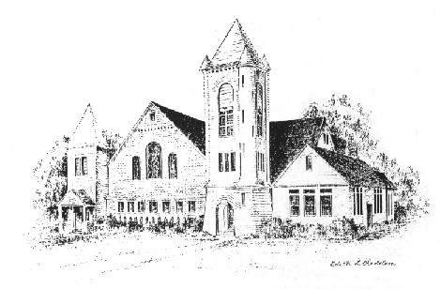
Sayville Congregational United Church of Christ
For more than a century and a half, the Sayville Congregational Church has served families on the South Shore and been a voice for the progressive Protestant tradition. A member of the United Church of Christ since it was established in 1957, today we continue to celebrate God's love, to speak for the oppressed, and to welcome those rejected by other churches. To learn about membership, please speak with any deacon.

Music Director Sean Cameron
Greeter/Usher Ron Bergmann
Liturgist Michael Jayne
Communion Elements Mark & Karin Conrad
Projection Slides Kimberley Reiser
Projectionist Casey Cunningham
Hospitality All the People
Pastor: Ray Bagnuolo, ray@sayvilleucc.org 631-827-8611 (Cell/Text)

Sayville Congregational United Church of Christ
131 Middle Road, Sayville, NY 11782
631-589-1519; churchadmin@sayvilleucc.org
www.sayvilleucc.org; www.facebook.com/sayvilleucc
Heather Corcoran, Church Administrator; eChimes Editor

Thank you for being with us today.
Peace. Shalom. Salaam. For the ways of peace are many.
“Namaste”

Please use the enclosed form to order Easter Plants for our Chancel.
Orders are due on Wednesday, April 5th.
Please contact Heather if you have questions or need any additional help.

