Sayville Congregational United Church of Christ

Palm Sunday
April 9, 2017

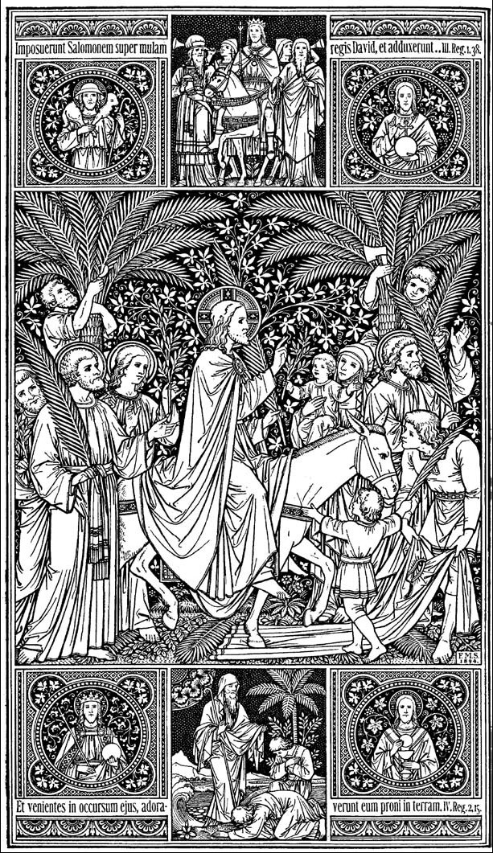

Ray Welcome
Bell Ringer/Sean Bell is rung after the welcome at least 10 times.
Sean will begin playing around the 10th ring of the bell.

Sean & Bob Acker Prelude “Open the Gates of the Temple” Words by Frances Jane Crosby; Music by Joseph F. Knapp; Bob Acker, soloist.

Liturgist Read Call to Worship from the rear of the sanctuary. Processional holds.

*Please join me in the call to worship:
*Call to Worship

Blessed be the one who comes in the name of God.
Hosanna in the Highest!
Again we say! Blessed be the one who comes in the name of God.
Hosanna in the Highest!
Yes! Blessed be the one who comes in the name of God.
Hosanna in the Highest!

*Processional Hymn New Century Hymnal #216 All Glory, Laud, and Honor
Processional:
- Ray moves to right of chancel
- Liturgist moves to lectern standing there through the hymn
- Choir continues to the pews
- Choir sits at the end of the hymn (all are seated)
- Liturgist remains standing to read and lead the Unison Prayer
Please be seated for the Unison Prayer

Liturgist Unison Prayer “Please join me in praying our Unison Prayer”
We stand humbly before you, O God.
You have redeemed us all through this Christ Jesus.
You have reminded us that through this Christ we are yours.
The branches and the leaves speak out for all creation,
“This One. Listen to this One.”
We know you through this Jesus -
Let us remember to know you for others
As Jesus did for us.”

- Liturgist is seated at the end of the Unison Prayer
- A moment of silence follows.
- When ready, Ray moves to the lectern:

Ray Assurance of Pardon
“Listen. Listen to this One.” All of us, listen. Hear the words in your heart of Jesus’s voice, the teachings of how much God loves us; pardons and forgives us; and loves us even more.

Ray Passing of the Peace

Liturgist waits for Ray to return to his seat before beginning the readings.

Liturgist First Reading Psalm 118: 1-2; 5-7a (Adapted)
Give thanks to God, for God is good;
God’s steadfast love endures forever!
Let us all say,
“God’s steadfast love endures forever.”
Out of our distress we call on God;
God answers us and sets us in a broad place.
With God on our side we do not fear.
What can mortals do to us?
God is on our side to help us.
Let us all say,
“God’s steadfast love endures forever.”

Choir Musical Praise “Hosanna, Loud Hosanna” Arranged by Mark Hayes
Featuring our youth.

Liturgist Gospel Reading Matthew 21:1-11

When they neared Jerusalem, having arrived at Bethphage on Mount Olives, Jesus sent two disciples with these instructions: “Go over to the village across from you. You’ll find a donkey tethered there, her colt with her. Untie her and bring them to me. If anyone asks what you’re doing, say, ‘The Master needs them!’ He will send them with you.”
(Continued next page)
This is the full story of what was sketched earlier by the prophet:
Tell Zion’s daughter,
“Look, your king’s on his way,
poised and ready, mounted
On a donkey, on a colt,
foal of a pack animal.”
The disciples went and did exactly what Jesus told them to do. They led the donkey and colt out, laid some of their clothes on them, and Jesus mounted. Nearly all the people in the crowd threw their garments down on the road, giving him a royal welcome. Others cut branches from the trees and threw them down as a welcome mat. Crowds went ahead and crowds followed, all of them calling out, “Hosanna to David’s son!” “Blessed is he who comes in God’s name!” “Hosanna in highest heaven!”

As he made his entrance into Jerusalem, the whole city was shaken. Unnerved, people were asking, “What’s going on here? Who is this?”

The parade crowd answered, “This is the prophet Jesus, the one from Nazareth in Galilee.”

Here end this morning’s readings.

Ray Message for All Gathered (Youth & Adults)

Choir Musical Praise “He Shall Feed His Flock/Come Unto Him”
From Handel’s Messiah; Karen Maust, Soprano Solo

A moment for reflection… Ray will cue Sean when to start hymn.

All Hymn NCH #215 Ride On! Ride On in Majesty

Liturgist Prayer for Others and Ourselves
At this time, you are invited to lift up your joys and concerns before God and one another. Please wait for me to come around with the microphone so everyone can hear your request. You are also welcome to write your joys and concerns on the prayer card in the pew, placing it in the collection basket during the offertory. May we hear your joys and concerns?
Ray Let us pray…followed by The Lord’s Prayer/The Prayer of Jesus

Choir Musical Praise “Les Rameaux” by Jean –Baptiste Faure,
Bob Acker soloist

Liturgist Invitation to Give
Thank you for your generosity in helping us to share God's love for all. We are grateful for all the ways you participate in the work of this ministry, and more than anything, we are most grateful that you are here. We welcome your offerings at this time and invite you to place your prayer and information cards in the basket.

Sean Offertory Liturgist returns to the lectern for the Doxology

All *Doxology We praise thee, O God, our Redeemer, Creator
in grateful devotion our tribute we bring.
We lay it before thee, we come and adore thee,
we bless your holy name, glad praises we sing. Amen.

Ray Preparing for the Distribution of Palms

All *Closing Hymn NCH #304 All Hail the Power of Jesus’ Name

Ray Benediction and Sending Forth

Bell Ringer Bell is rung several times. Let it ring and then a minute of silence, Ray may follow with the singing bowl…will let you know ahead of time.

Choir Choral Blessing “Amen” from Elijah by Felix Mendelssohn

Sean Postlude “Trumpet Concerto, 1st movement” by Johann Nepomuk Hummel Joshua Lurie, trumpet soloist

Please remain seated for announcements and distribution of palms.

Announcements!
Today!
Please join us for refreshments after worship in the Vestry
“A Talkback!” will follow today’s service from 11:25 - Noon! All are welcome!

New Neighbor Mailings! – During Fellowship

Upcoming Worship Schedule

Lenten, Passion Week and Easter Worship
April 13 Maundy Thursday 8:00 PM
April 14 Good Friday Sanctuary Open 11 AM – 4:00 PM
April 16 Easter Sunday Colossians 3:1-4; Matthew 28:1-10

Sunrise Service Depart Sayville Ferry at 6:00 AM; Board 5:45 AM
Breakfast at Fellowship Hall after the cruise.

Easter Morning Service 10:00 AM – Sanctuary

Elder & Trustee Meetings for April
Elders on Monday, April 10th at 7:00 PM
Trustees on Monday, April 17th at 7:00 PM

Weekly Events:
- Bible Talks! in the Vestry - Mondays at 11:45 AM & Tuesdays at 7:00 PM
- Choir Practice in the Vestry - Wednesdays at 6:00 PM
- Having Friends Inn in Fellowship Hall - Mondays through Thursdays at 5:30 PM
- NA Meetings in Fellowship Hall – Mon & Wed. at 7:30 PM; Sat. at 11:00 AM
- Prayer Shawl Ministry in the Vestry - Thursdays at 10:00 AM
- Senior Exercise in the Vestry - Tuesdays at 9:30 AM & Thursdays at 12:15 PM

Giving:
United Church of Christ congregations pays its own bills, hires its own staff, and maintains its own facilities from the voluntary gifts of members and friends. Donations are accepted in the basket on Sundays, as well as through our online giving program or through direct payments. Please call Heather in the office to answer any questions you may have about how we can best to accommodate your gifts. And, please consider buying Stop & Shop Gift Cards to support the church. Available at coffee hour each week, a portion of their cost goes to Sayville Congregational United Church of Christ.

Live Stream Video of Forum from April 2 with Sister Sanaa Nadim
Thank to everyone who joined us last week for our forum with Sister Sanaa Nadim, Muslim Chaplain from Stony Brook University. A video of the 90 minute forum, along with questions and answers from those gathered can be viewed from our webpage at www.sayvilleucc.org or on Facebook at www.facebook.com/sayvilleucc. Fast forward to 15:00 for the beginning of the live streaming that was recorded.

Newsletters: Are you receiving our weekly newsletters: eChimes and Justice Chimes Newsletters? Let us know: ray@sayvilleucc.org. Visit our website for more information. at www.sayvilleucc.org. Do you need these in print?

Hospitality Hosts, Greeters, Ushers, Projectionists Needed! Please sign up to assist in worship for Sundays throughout 2017 If you can help in any of these ways, Sign up on the forms in the hallway or contact Sue Lanchantin for more information.

Easter Sunday Readings:

Colossians 3:1-4

So if you’re serious about living this new resurrection life with Christ, act like it. Pursue the things over which Christ presides. Don’t shuffle along, eyes to the ground, absorbed with the things right in front of you. Look up, and be alert to what is going on around Christ—that’s where the action is. See things from his perspective.
Your old life is dead. Your new life, which is your real life—even though invisible to spectators—is with Christ in God. He is your life. When Christ (your real life, remember) shows up again on this earth, you’ll show up, too—the real you, the glorious you. Meanwhile, be content with obscurity, like Christ.

Matthew 28:1-10

After the Sabbath, as the first light of the new week dawned, Mary Magdalene and the other Mary came to keep vigil at the tomb. Suddenly the earth reeled and rocked under their feet as God’s angel came down from heaven, came right up to where they were standing. He rolled back the stone and then sat on it. Shafts of lightning blazed from him. His garments shimmered snow-white. The guards at the tomb were scared to death. They were so frightened, they couldn’t move.
The angel spoke to the women: “There is nothing to fear here. I know you’re looking for Jesus, the One they nailed to the cross. He is not here. He was raised, just as he said. Come and look at the place where he was placed.
“Now, get on your way quickly and tell his disciples, ‘He is risen from the dead. He is going on ahead of you to Galilee. You will see him there.’ That’s the message.”
The women, deep in wonder and full of joy, lost no time in leaving the tomb. They ran to tell the disciples. Then Jesus met them, stopping them in their tracks. “Good morning!” he said. They fell to their knees, embraced his feet, and worshiped him. Jesus said, “You’re holding on to me for dear life! Don’t be frightened like that. Go tell my brothers that they are to go to Galilee, and that I’ll meet them there.”

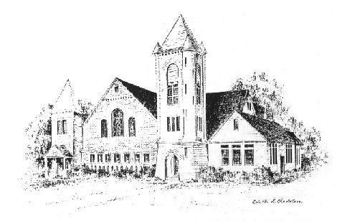
Sayville Congregational United Church of Christ
For more than a century and a half, Sayville's Congregational Church has served families on the South Shore and been a voice for the progressive Protestant tradition. A member of the United Church of Christ since it was established in 1957, today we continue to celebrate God's love, to speak for the oppressed, and to welcome those rejected by other churches. To learn about membership, please speak with any deacon.

Music Director Sean Cameron
Greeter/Ushers Kathy Leis and Sue Lanchantin
Liturgist Karen Maust
Projection Slides Kimberley Reiser
Projectionist Casey Cunningham
Hospitality The Maust Family
Closing the Doors Kathy Leis
Pastor: Ray Bagnuolo, ray@sayvilleucc.org 631-827-8611 (Cell/Text)

Sayville Congregational United Church of Christ
131 Middle Road, Sayville, NY 11782-3101
631-589-1519; churchadmin@sayvilleucc.org
www.sayvilleucc.org; www.facebook.com/sayvilleucc
Heather Corcoran, Church Administrator; eChimes Editor

Thank you for being with us today.
Peace. Shalom. Salaam. For the ways of peace are many.
“Namaste”

