The Fourth Sunday of Easter
Communion Sunday
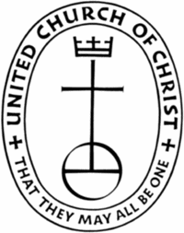
Sayville Congregational United Church of Christ
Sunday, May 7, 2017

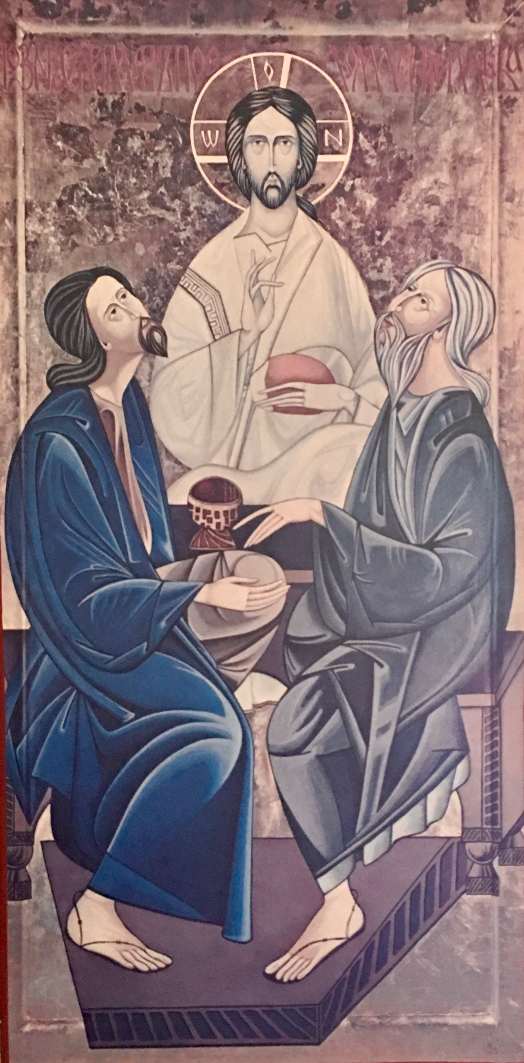

Meditation

“We encounter God in the face of the stranger. That, I believe, is the Hebrew Bible’s single greatest and most counterintuitive contribution to ethics… The human other is a trace of the Divine Other.” ~ Rabbi Jonathan Sacks, The Dignity of Difference

Then the two travelers went over everything that had happened on the road
and how they recognized the stranger as Jesus when he broke the bread.
Luke 24:35

Welcome

Ringing of the Bell

Prelude Trumpet and Organ Music James Cesare

*Call to Worship (Adapted from 2 Peter 1:3-4)

God’s divine power has given us
everything
everything we need for life
everything we need for godliness
everything we need.
We are called by God’s glory.
We are called by God’s goodness.
And we are here, receiving God’s promises.
God’s precious and very great promises.
Let us be open to what God offers.
Let us worship God together with hope and gratitude.

*Processional Hymn SPP #33 There’s A Spirit of Love in This Place

Unison Prayer (Together)
God, you know how we are. We forget that you are everywhere.
We think that only certain words can define you.
We naturally limit you because of our own limitations.
Yet, deep within us is more of you than we know.
All around us is more than of you than we know.
You fill our every breath.
You have made every grain of existence on this and all the universes there may be.
Forgive us when we forget how loving, powerful and everywhere you are.
Help us to get out of our own way, so we may know you even more;
so we may know your light from the inside;
so we may live into you for you in all the ways we know you,
in all the ways we may. Amen.

Assurance of Pardon (Variation of the voice a Buddhist Sutra hears of the Bodhisattva)

The wondrous voice, the voice of the one
who attends to the cries of the world
The noble voice, the voice of the rising tide
surpassing all the sounds of the world
Let our mind be attuned to that voice, now
And know the love and pardon bestowed upon us.

*Passing of the Peace

Reading Acts 2:42-47
The Message (MSG) (Adapted) King James Version (KJV)

That day about three thousand took him at his word, were baptized and were signed up. They committed themselves to the teaching of the apostles, the life together, the common meal, and the prayers.
Everyone around was in awe—all those wonders and signs done through the apostles! And all the believers lived in a wonderful harmony, holding everything in common. They sold whatever they owned and pooled their resources so that each person’s need was met.
They followed a daily discipline of worship in the Temple followed by meals at home, every meal a celebration, exuberant and joyful, as they praised God. People in general liked what they saw. Every day their number grew as God added those who were saved.

And they continued steadfastly in the apostles' doctrine and fellowship, and in breaking of bread, and in prayers.
And fear came upon every soul: and many wonders and signs were done by the apostles.
And all that believed were together, and had all things common;
And sold their possessions and goods, and parted them to all men, as every man had need.
And they, continuing daily with one accord in the temple, and breaking bread from house to house, did eat their meat with gladness and singleness of heart,
Praising God, and having favour with all the people. And the Lord added to the church daily such as should be saved.

Here ends this morning’s readings.

Musical Praise “I will Sing With the Spirit” by John Rutter

A Message for All Gathered

A moment for reflection…
*Hymn NCH #332 As We Gather at Your Table

Prayer for Others and Ourselves

The Lord's Prayer – The Prayer of Jesus (Please say this prayer as you know it.)

Invitation to Give
Thank you for your generosity in helping us to share God's love for all. We are grateful for all the ways you participate in the work of this ministry, and more than anything, we are most grateful that you are here. We welcome your offerings at this time and invite you to place your prayer and information cards in the basket.

Offertory

*Doxology
We praise thee, O God, our Redeemer, Creator;
in grateful devotion, our tribute we bring.
We lay it before thee, we come and adore thee,
We bless thy holy name, glad praises we sing. Amen.

Invitation to the Table

Jesus said:
I am the bread of life.
You who come to me shall not hunger;
You who believe in me shall never thirst.

In company with all who hunger for spiritual food,
we come to this table to know the risen Christ
in the sharing of this life-giving bread.

Communion Prayer
God be with you.
And also with you.

Lift up your hearts.
We lift them up to God.

Let us give thanks to God Most High.
It is right to give God thanks and praise.

Pastor continues with the Communion Prayer…

Church Covenant (Sung in Unison)
In response to God’s love, we covenant with each other
to be faithful to the demands and inspiration of the eternal spirit,
revealed in the event of Jesus Christ;
to accept and respect each other with love and concern
in our worship and witness;
to reach out with the courage of our convictions in the cause of justice, liberation and equality for all;
In this, we covenant to keep the ultimate promise; “I care, I am with you.”

Sharing of the Elements:
Leader: These are the gifts of God for the people of God.

Communion Responses: The Bread of Life ~ The Cup of Blessing

Prayer of Thanksgiving
We thank you God, for inviting us to this table to remember your active presence and call in our lives. We are grateful for the new and right spirit of this communion with you today, tomorrow and every day. May it be so. Amen.

*Hymn NCH #336 “Here, O Lord,, I See You Face to Face”
Verses 1, 3, 5

Benediction and Sending Forth

Bell is Run

Choral Blessing “A Closing Prayer” by Don Besig

Postlude “The Impossible Dream” from The Man of La Mancha
Lyrics by Joe Darion, Music by Mitch Leigh
Sean Cameron, Soloist

A Time for Brief Announcements

Announcements!
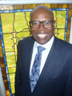
Elders Meeting on Monday, May 8, 2017 – 7:30 PM
Pre-School Board Meeting, May 11th at 7:30 PM

Next Sunday, Rev. Freeman Palmer, Associate Conference Minister for Congregational Development of the United Church of Christ will be our guest preacher. Freeman’s a good friend of our congregation!
Please join us!

For those who wish…
“A Talkback!” will follow the forum that begins at the end of worship and continues in the vestry. All are welcome!

Thank you to everyone who
participated in yesterday’s Spring Clean-up!

Accompaniment Ministry Opportunities

We are reaching out to request accompaniment for three critical immigration hearings. Since all of the cases are scheduled at NYC immigration courts, there will be no limit to the number of volunteers. The more support we have the better, especially since two of the cases are for young immigrants, one minor, and another is for David, a father of three.
Javier; 26 Federal Plaza, NYC; Thursday, May 11; 9:00 AM
David (Deportation Hearing); 201 Varick Street, NYC; Monday, May 15, 8:30 AM
If you are able to attend or would like more information, please contact Ray at 631-827-8611 or ray@sayvilleucc.org

Weekly Events:

Bible Talks! in the Vestry - Mondays at 11:45 AM & Tuesdays at 7:00 PM
This week we our consider John 14: 1-14.

Choir Practice in the Vestry - Wednesdays at 6:00 PM
Having Friends Inn in Fellowship Hall – Mon. through Thurs. at 5:30 PM
NA Meetings in Fellowship Hall – Mon. at 7:30 PM; Sat. at 11:00 – 1:00 PM
SA Meetings in Fellowship Hall – Wed. at 7:30 PM
Nar-Anon Meetings in Fellowship Hall – Thurs. at 6:45 PM
Prayer Shawl Ministry in the Vestry – Thurs. at 10:00 AM
Senior Exercise in the Vestry – Tues. at 9:00 AM & Thurs. at 12:15 PM

Got cards?
Marjean Postlethwaite, our former pastor Trevor's widow, is now living in the Memory Care Unit of the Jones Harrison Residence, where she was the organist and Trevor was the Pastor during their "retirement" in Minneapolis. Her daughter Martha tells us she is very "with it", and that she loves to get mail and calls, giving us permission to share her contact information. If you want more info, call Connie 631-567-9411.
Marjean Postlethwaite,
Jones Harrison Residence
Devon Court #244
3700 Cedar Lake Avenue, Minneapolis, MN 55416
Phone: 612-925-7160 (let it ring many times, please)

Giving:
United Church of Christ congregations pays its own bills, hires its own staff, and maintains its own facilities from the voluntary gifts of members and friends. Donations are accepted in the basket on Sundays, as well as through our online giving program or through direct payments. Please call Heather in the office to answer any questions you may have about how we can best to accommodate your gifts. And, please consider buying Stop & Shop Gift Cards to support the church. Available at coffee hour each week, a portion of their cost goes to Sayville Congregational United Church of Christ.

Newsletters: Are you receiving our weekly newsletters: eChimes and Justice Chimes Newsletters? Let us know: ray@sayvilleucc.org. Visit our website for more information. at www.sayvilleucc.org. Do you need these in print?

Hospitality Hosts, Greeters, Ushers, Projectionists Needed! Please sign up to assist in worship for Sundays throughout 2017 If you can help in any of these ways, Sign up on the forms in the hallway or contact Sue Lanchantin for more information.

Thank you for being with us today. Please contact Ray or the office if there is anything we can do to be of help during the week! Hope to see you next Sunday!

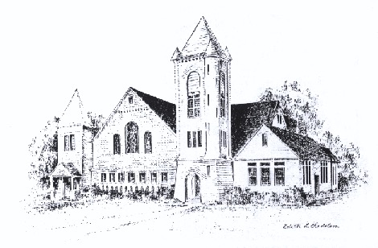

Sayville Congregational United Church of Christ

For more than a century and a half, Sayville's Congregational Church has served families on the South Shore and been a voice for the progressive Protestant tradition. A member of the United Church of Christ since it was established in 1957, today we continue to celebrate God's love, to speak for the oppressed, and to welcome those rejected by other churches. To learn about membership, please speak with any deacon.

Today’s Leadership

Liturgist Kimberley Reiser
Choir With appreciation for all our choir members.
Accompaniment James Cesare, Trumpet
Music Director Sean Cameron
Greeter/Ushers Don and Alice Gray
Projection Slides Kimberley Reiser
Projectionist Casey Cunningham
Hospitality Thank you!

Sayville Congregational United Church of Christ
131 Middle Road, Sayville, NY 11782-3101
631-589-1519; churchadmin@sayvilleucc.org
www.sayvilleucc.org; www.facebook.com/sayvilleucc
Heather Corcoran, Church Administrator; eChimes Editor
Ray Bagnuolo, Pastor ray@sayvilleucc.org 631-827-8611 (Cell/Text)

Thank you for being with us today.
Peace. Shalom. Salaam. For the ways of peace are many.
“Namaste”

Please contact Heather if you have questions or need any additional help.

